|  |  |
| --- | --- |
|  | 1. Design Form using JavaScript /HTML /JQuery with client-side validations on the given problem |

|  |  |  |  |
| --- | --- | --- | --- |
| **Name of Student** |  | **Roll No.** |  |
| **Sign here to indicate that you have read all relevant material provided /available on Moodle while performing and writing this experiment** | | **Sign:** | |

**Late Submission Details (if any)**

|  |  |  |
| --- | --- | --- |
| **Reason(s) of late submission** | **Date of practical performance** | **Date of practical submission** |
|  |  |  |

**References used**

|  |  |  |
| --- | --- | --- |
| 1 | Name and author of reference book(s) with page nos. |  |
| 2 | Name and roll nos. of the peers whose help you have taken (if any) |  |

|  |  |  |  |  |  |  |  |  |  |  |  |  |  |  |  |  |  |  |  |  |
| --- | --- | --- | --- | --- | --- | --- | --- | --- | --- | --- | --- | --- | --- | --- | --- | --- | --- | --- | --- | --- |
| **Rubrics for assessment of Experiment:**   |  |  |  |  | | --- | --- | --- | --- | | Indicator | Poor | Average | Good | | Timeliness  Maintains Experiment deadline (3) | Experiment not done (0) | One or More than One week late (1-2) | Maintains deadline (3) | | Completeness and neatness  Complete all parts of Experiment (3) | N/A | < 80% complete (1-2) | 100% complete (3) | | Originality  Extent of plagiarism (2) | Copied it from someone else (0) | At least try to implement but could not succeed (1) | Implemented (2) | | Knowledge  In depth knowledge of the Experiment (2) | Unable to answer any questions (0) | Unable to answer few questions (1) | Able to answer all questions (2) | |
| **Assessment Marks:**   |  |  | | --- | --- | | Timeliness |  | | Completeness and neatness |  | | Originality |  | | Knowledge |  | | Total |  | |

**Signature of Teacher with date**

|  |  |
| --- | --- |
| **1.** | **Course, Subject & Experiment Details** |

|  |  |  |  |
| --- | --- | --- | --- |
| **Course & Branch** | **T.E. (ECS)** | **Estimated Time** | **02 Hours Per Week** |
| **Current Semester** | **Semester V** | **Subject Name** | **WT** |
| **Chapter No. & Unit** | **3 (Complete)** | **Chapter Title** | **HTML, CSS, Bootstrap** |
| **Experiment Type** | **Software Performance** | **Subject Code** | **ECC 502** |

|  |  |
| --- | --- |
| **2.** | **Aim & Objective of Experiment** |

1. Design a web form using Javascript / Jquery for given problem statement. (CO3)

|  |  |
| --- | --- |
| **3.** | **Expected Outcome of Experiment** |

1. To understand applications of Javascript / Jquery to build a web form
2. To understand applications of Javascript / Jquery to animate the web page

|  |  |
| --- | --- |
| **4.** | **Code of the experiment** |

1. **HTML / Javascript / Jquery code of the form (with client side validation)**

<!DOCTYPE html>

<html lang="en" dir="ltr">

<head>

<meta charset="utf-8">

<script src="https://kit.fontawesome.com/7cf8b731c0.js" crossorigin="anonymous"></script>

<link rel="stylesheet" href="https://cdn.jsdelivr.net/npm/bootstrap@4.5.3/dist/css/bootstrap.min.css"

integrity="sha384-TX8t27EcRE3e/ihU7zmQxVncDAy5uIKz4rEkgIXeMed4M0jlfIDPvg6uqKI2xXr2" crossorigin="anonymous">

<link rel="preconnect" href="https://fonts.gstatic.com">

<link href="https://fonts.googleapis.com/css2?family=Bree+Serif&display=swap" rel="stylesheet">

<link rel="stylesheet" href="{{ url_for('static', filename = '/css/login.css')}}">

<title></title>

</head>

<body>

<div class="header" id="topheader">

<nav class="navbar navbar-expand-lg navbar-light bg-light fixed-top">

<div class="container text-uppercase p-2">

<a class="navbar-brand" href="/index"><i class="fa-solid fa-eye"></i> HAWK EYE</a>

<button class="navbar-toggler" type="button" data-toggle="collapse" data-target="#navbarSupportedContent"

aria-controls="navbarSupportedContent" aria-expanded="false" aria-label="Toggle navigation">

<span class="navbar-toggler-icon"></span>

</button>

<div class="collapse navbar-collapse" id="navbarSupportedContent">

<ul class="navbar-nav ml-auto">

<li class="nav-item active">

<a class="nav-link" href="/index">Home <span class="sr-only">(current)</span></a>

</li>

<li class="nav-item">

<a class="nav-link" href="/contact">Contact Us <span class="sr-only">(current)</span></a>

</li>

</ul>

</div>

</div>

</nav>

</div>

<section class="form my-4 mx-5">

<div class="container">

<div class="row no-gutters">

<div class="col-lg-5">

</div>

<div class="col-lg-12 ">

<h1 class="font-weight-bold py-3">Registration Form</h1>

<form action="/registration" method="post">

<div class="form-row">

<div class="col-lg-4 col-4">

<input type="text" placeholder="Name" name="name" value="" class="form-control" my-3 p-3>

</div>

</div>

<div class="form-row">

<div class="col-lg-4 col-4">

<input type="text" placeholder="Username" name="username" value="" class="form-control" my-3 p-3>

</div>

</div>

<div class="form-row">

<div class="col-lg-4 col-4" style="text-align: left;">

<label>Select Domain</label>

<select name="domain">

<option value="Manager">Manager</option>

<option value="Security">Security</option>

</select>

</div>

</div>

<div class="form-row">

<div class="col-lg-4 col-4">

<input type="text" placeholder="Identity Number" name="idno" value="" class="form-control" my-3 p-3>

</div>

</div>

<div class="form-row">

<div class="col-lg-4 col-4">

<input type="password" placeholder="Password" name="pword" value="" class="form-control" my-3 p-3>

</div>

</div>

<div class="form-row">

<div class="col-lg-4 col-4">

<button type="submit" class="btn btn-primary" name="button">Submit</button>

</div>

</div>

<div style="text-align: center;">

Already have an account.<br><a href="/ManagerLogin">Manager Login</a><br><a href="/SecurityLogin">Security

Login</a>

</div>

</form>

</div>

</div>

</div>

</section>

</html>

1. **Explain the features that you have implemented in the form with the help of appropriate screenshots**

**A simple registration portal for the end user. This type of registration could be useful for freshers who recently joined the company.**

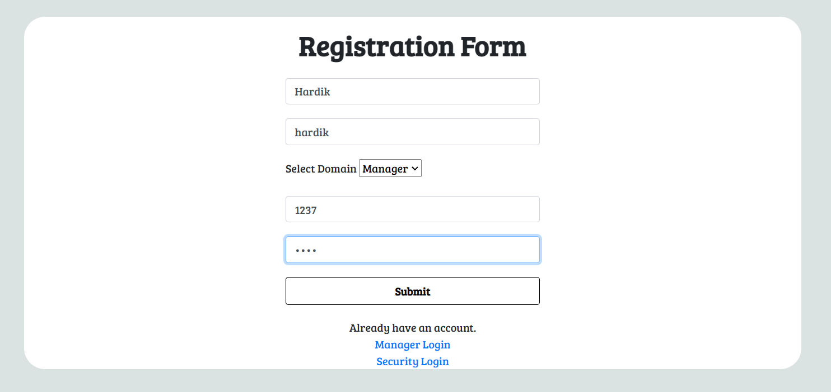

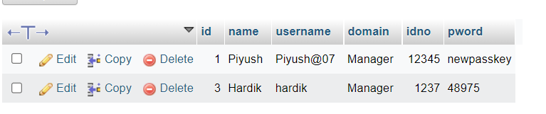

**Both security and manager have different login pages.**

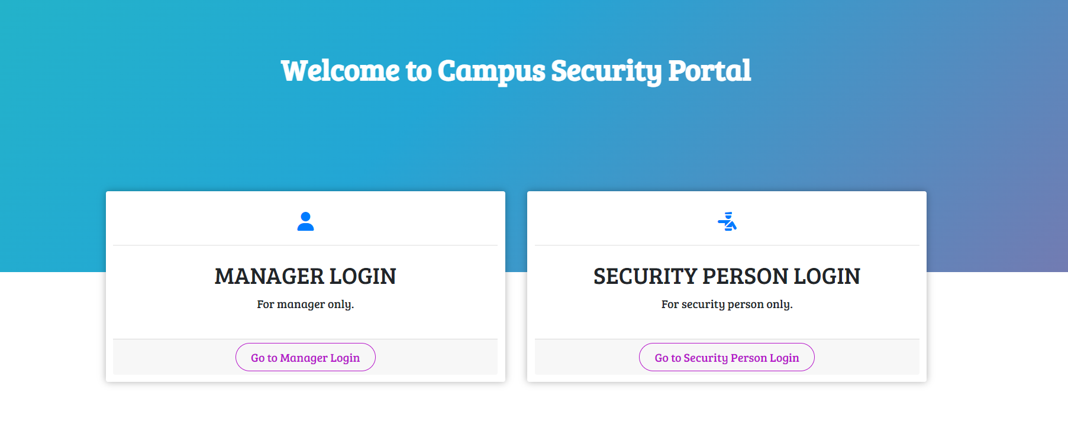

|  |  |
| --- | --- |
| **5.** | **Conclusions & Inferences** |

|  |  |
| --- | --- |
| **6.** | **Post Lab exercise** |

Hide the contents of the main page of your website that you have created in experiment 2 initially. When the page is loaded, fade in the contents slowly

.

**Write the code of post lab question:**

******************